Task 2 – SQL Database Setup and Query Analysis Using Dataset 1

Step 1: Database and Table Setup
Objective: To verify the database and the structure of the tables created for the space-mission dataset.
Database Name: data_foundation
Tables Used:
- space_missions — stores mission details, including mission name, target, launch date, agency, and status.
- mission_observations — stores observation details, including region, distance, signal strength, and data collected.
SQL Concepts Used: USE, SHOW TABLES, and DESCRIBE.
Observation: The database and table structures were checked in MySQL Workbench.
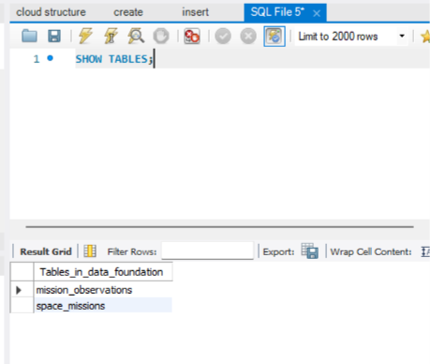
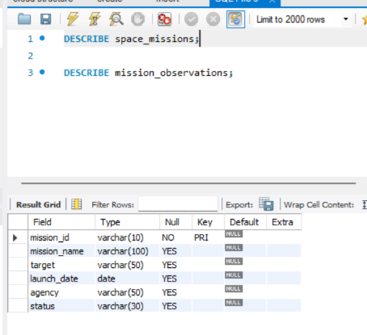

Step 2: Data Loading and Verification
Objective: To verify that the space-mission dataset has been loaded correctly into the database.
SQL Concepts Used: SELECT, COUNT(), and column aliases using AS.
Verification Performed:
- Retrieved all records from the space_missions table.
Expected Result: The database contains 10 mission records and 10 observation records.
Finding: The data retrieval and record counts help confirm that the dataset is available for further SQL analysis
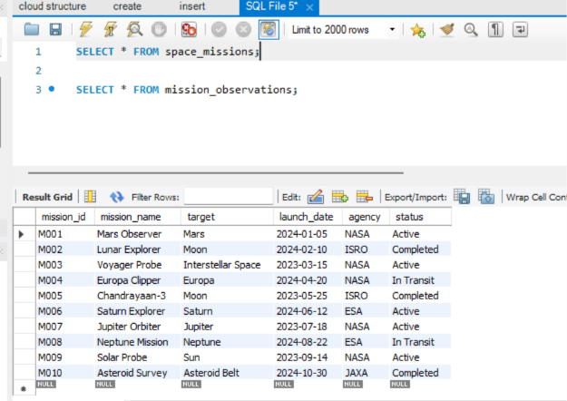

Step 3: SQL Query 1 — Filtering and Sorting Missions
Objective: To identify active space missions launched in 2024 and display them in chronological order.
SQL Concepts Used: SELECT, WHERE, AND, date filtering, and ORDER BY ASC.
Query: The SQL statement retrieves the mission ID, mission name, target, launch date, and agency for active missions launched between January 1, 2024, and December 31, 2024.
Finding: The output identifies the active missions that satisfy the specified conditions and shows their launch sequence.
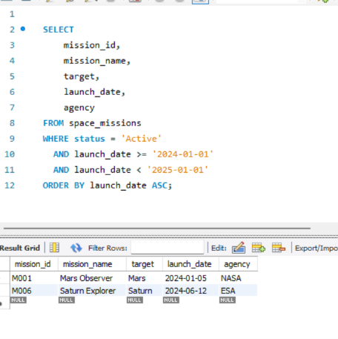

Query 2: Regional Observation Analysis
Objective: To compare space observations across different regions and identify how much data was collected in each region.
SQL Concepts Used: GROUP BY, COUNT(), AVG(), SUM(), ROUND(), and ORDER BY DESC.
Purpose: The query groups observations by region and calculates the number of observations, average signal strength, and total data collected in each region.
Finding: The results help identify regions with higher data collection and compare their average signal strength. The region with the highest total data collected appears at the top of the output.
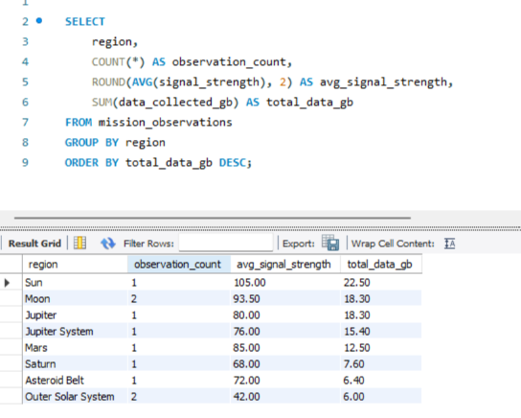

Query 3: Combining Mission and Observation Data Using JOIN
Objective: To combine mission details with their corresponding observation records and compare their data collection.
SQL Concepts Used: INNER JOIN, table aliases, ON, and ORDER BY DESC.
Purpose: The query joins the space_missions and mission_observations tables using their common mission_id column. It displays the mission name, agency, target, observation region, distance, and data collected.
Finding: The results show how observation data relates to individual missions. Sorting by data collected makes it easy to identify the missions with the highest data collection.
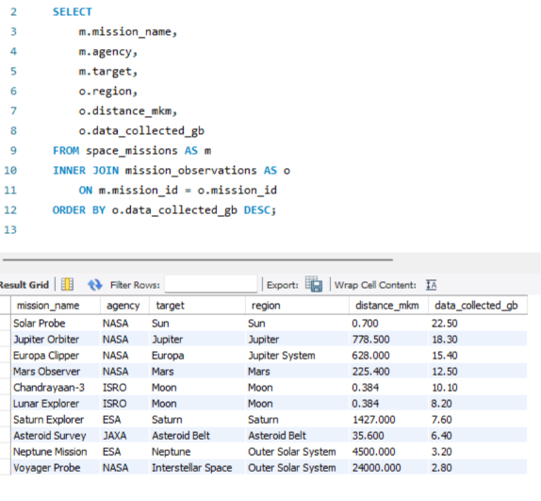

Query 4: Identifying Above-Average Data Collection
Objective: To identify missions whose data collection exceeds the overall average.
SQL Concepts Used: Subquery, AVG(), WHERE, INNER JOIN, and ORDER BY DESC.
Purpose: The inner query calculates the average data collected across all observation records. The outer query selects missions whose data collection is greater than that average.
Finding: The results identify missions with above-average data collection. This helps compare mission performance against the dataset's overall average.
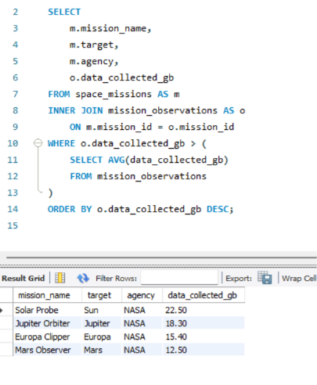

Conclusion :
The space-mission dataset was stored in MySQL using two related tables: space_missions and mission_observations. Four SQL queries were used to explore and analyse the data.
The queries demonstrated filtering and sorting, grouping and aggregate calculations, joining related tables, and using a subquery to compare data collection against the overall average. These operations helped identify active missions launched in 2024, compare observations across regions, relate mission details to observation records, and identify missions with above-average data collection.
Overall, the task provided practical experience in database querying and extracting useful information from structured data.

